**PROBLEM SOLVING & PYTHON PROGRAMMING - LAB**

**SUBJECT CODE : 21CS102**

**EXPT.NO:1**

* **DRAWING FLOWCHARTS AND WRITING ALGORITHMS FOR GIVEN PROBLEMS.**

**NAME : SAFEERUL HASAN M**

**ROLL.NO : 22CSEA57**

**CLASS : I CSE A**

**DATE : 24.11.2022**

1.1 ELECTRICITY BILL CALCULATION

**AIM:**

**To draw flowchart and write algorithm for the given problem.**

**ALGORITHM:**

**Step1: Start**

**Step 2: Read the TMU and PMU**

**Step 3: Unit consumed=TMU-PMU**

**Step 4: Check Unit<=100**

**4.1: If True,display no amount to pay**

**4.2: If False go to Step 5**

**Step 5: Check Unit>100&& Unit<=200**

**5.1: If True,calculate amount=(Unit-100)*1.5,DC=18,FTC=20**

**5.2: If False go to Step 6**

**Step 6: Check Unit>200&&Unit<=500**

**6.1: If True,calculate amount=((Unit-100)*1.5)+((Unit-200)*3.5),DC=48,FTC=30**

**6.2:If False go to Step7**

**Step 7:Check Unit>500**

**7.1:If True,calculate amount=((Unit-100)*1.5)+((Unit-200)*3.5)+((Unit-500)*6.0),DC=100, FTC=75**

**7.2:If False go to Step 8**

**Step 8 :Calculate TM= amount+DC+FTC**

**Step 9: Print TM**

**Step 10: Stop**

**RESULT:**

**Thus the algorithm is written and flowchart is drawn for the given problem.**

**FLOWCHART(ELECTRICITY BILL):**

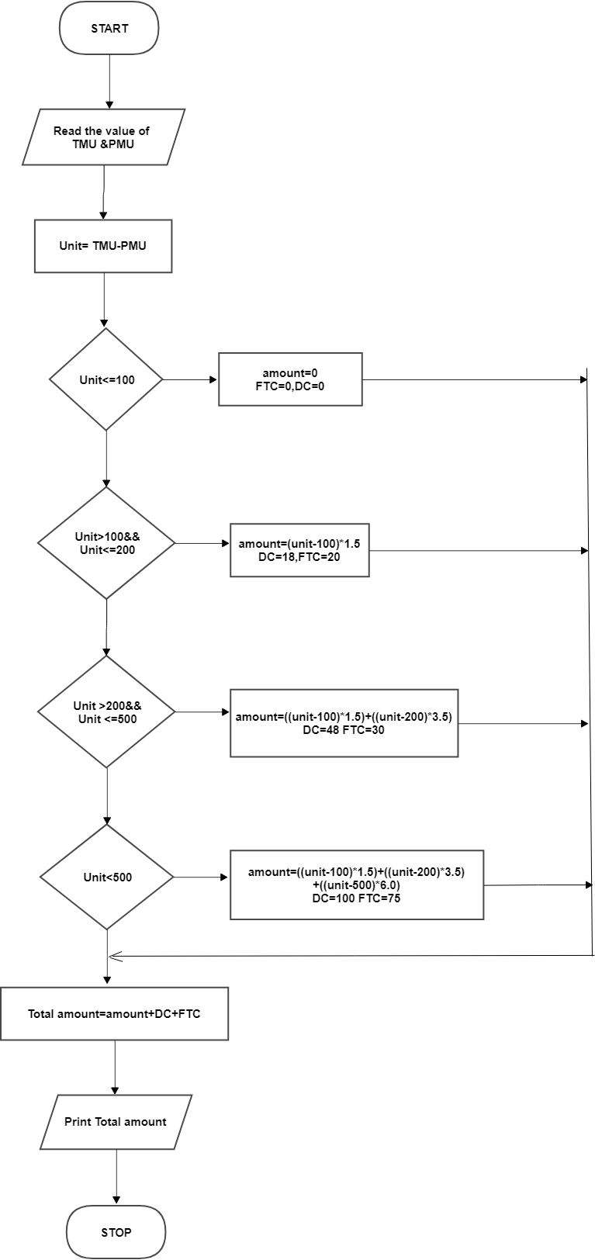

1.2 WEIGHT OF A STEEL ROD

**AIM:**

**To draw flowchart and write algorithm for the given problem.**

**ALGORITHM:**

**Step 1: Start**

**Step 2: Get the number of steel rods as n**

**Step 3: Initialize i=0 and total=0**

**Step 4: If i<=n**

**4.1: True, get the diameter of rod as d**

**4.1.1: Calculate unit weight = (d*d)/162**

**4.1.2: Get number of rods with diameter d**

**4.1.3: Calculate weight of the rod = n*d*unit weight**

**4.1.4: Add this weight to total**

**4.1.5: Increment value of I by 1**

**4.2: If False ,Display total as total weight of the rod**

**Step 5: Stop**

**RESULT:**

**Thus the algorithm is written and flowchart is drawn for the given problem.**

**Flowchart(weight of a steel rod):**

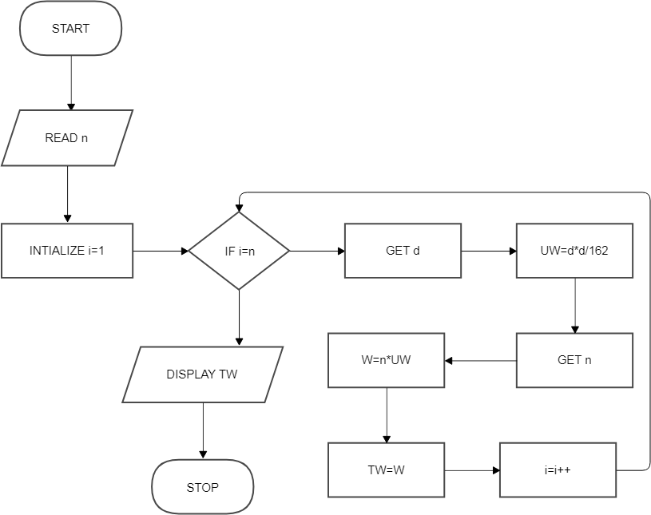

1.3 SINE SERIES

**AIM:**

**To draw flowchart and write algorithm for the given problem.**

**ALGORITHM:**

**Step 1: Start**

**Step 2: Get n**

**Step 3: initialie i=1, series=x**

**Step 4: If i<=n,If true, sum =( ((-1)**i)+(1**(2i+1)) )/(2i+1)!**

**4.1: series = series + sum**

**4.2: increment I value by i=i++,go to step 4**

**Step 5: If false ,go to step 6**

**Step 6: Print series**

**Step 7: Stop**

**RESULT:**

**Thus the algorithm is written and flowchart is drawn for the given problem.**

**FLOWCHART(SINE SERIES):**

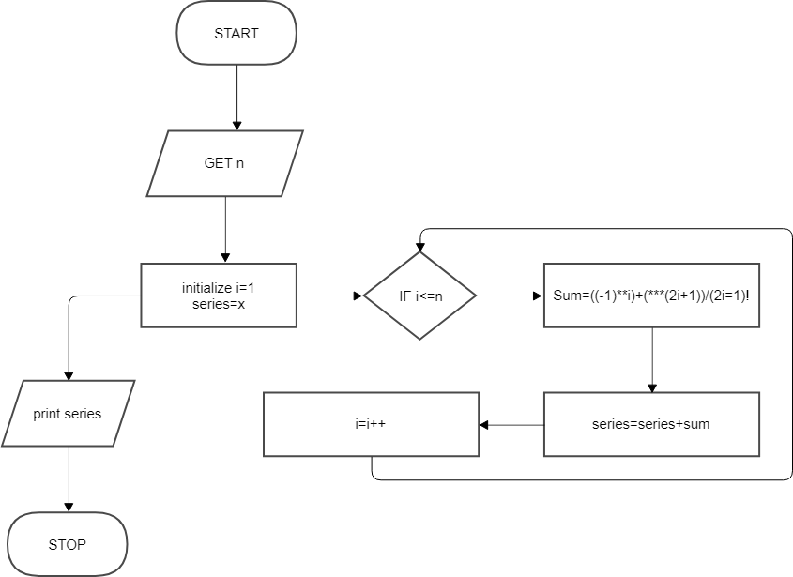

1.4 RETAIL SHOP BILLING

**AIM:**

**To draw flowchart and write algorithm for the given problem.**

**ALGORITHM:**

**Step 1: Start**

**Step 2: Get bill no and bill date**

**Step 3: Get details; name and address**

**Step 4: Get no. of items purchased as n**

**Step 5: Initialize i=0, total=0**

**Step 6: Check i<=n**

**6.1: if true, get item details like name, price, quantity and discount**

**6.1.1: calculate subtotal= (count*(price-discount))/100**

**6.1.2: Add the value of subtotal to total**

**6.1.3: increment the value i by 1**

**6.2: if false, get value of GST**

**6.2.1: calculate total bill= total + GST/100**

**Step 7: display total bill**

**Step 8: Stop**

**RESULT:**

**Thus the algorithm is written and flowchart is drawn for the given problem.**

**FLOWCHART(RETAIL SHOP BILLING):**

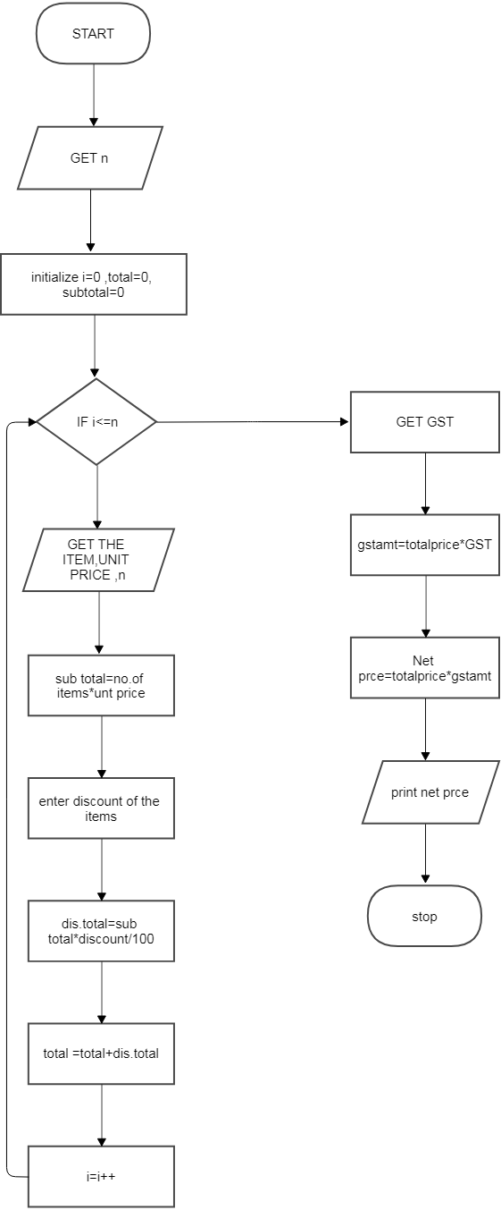

1.5 ELEC.CURRENT IN 3 PHASE AC CIRCUIT

**AIM:**

**To draw flowchart and write algorithm for the given problem**

**ALGORITHM:**

**Step 1: Start**

**Step 2: Read the values of pf , I and V**

**Step 3: Calculate P = (3^(1/2))*pf*I*V**

**Step 4: Display P**

**Step 5: Stop**

**RESULT:**

**Thus the algorithm is written and flowchart is drawn for the given problem.**

**FLOWCHART(ELEC.CURRENT IN 3 PHASE AC CIRCUIT)**

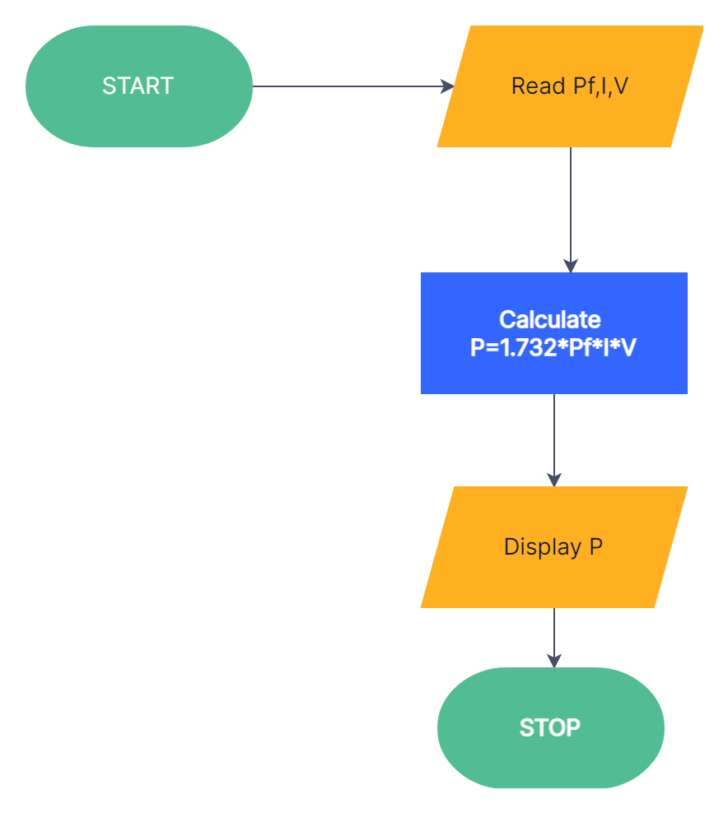

1.6 WEIGHT OF A MOTOR BIKE

**AIM:**

**To draw flowchart and write algorithm for the given problem.**

**ALGORTHM:**

**Step 1: Start**

**Step 2 : Get the GVWR, DW,RW, PW,FW.**

**Step 3: Calculate TW= FW+RW+DW+PW**

**Step 4: Get LV**

**Step 5: Calculate LW=TW+LV**

**Step 6: Calculate SW=GVMR-LW**

**Step 7: If SW>=0**

**7.1: If true, Display safe load**

**7.2: If false, Display heavy load**

**Step 8: Stop**

**RESULT:**

**Thus the algorithm is written and flowchart is drawn for the given problem.**

**FLOWCHART(WEIGHT OF A MOTOR BIKE):**

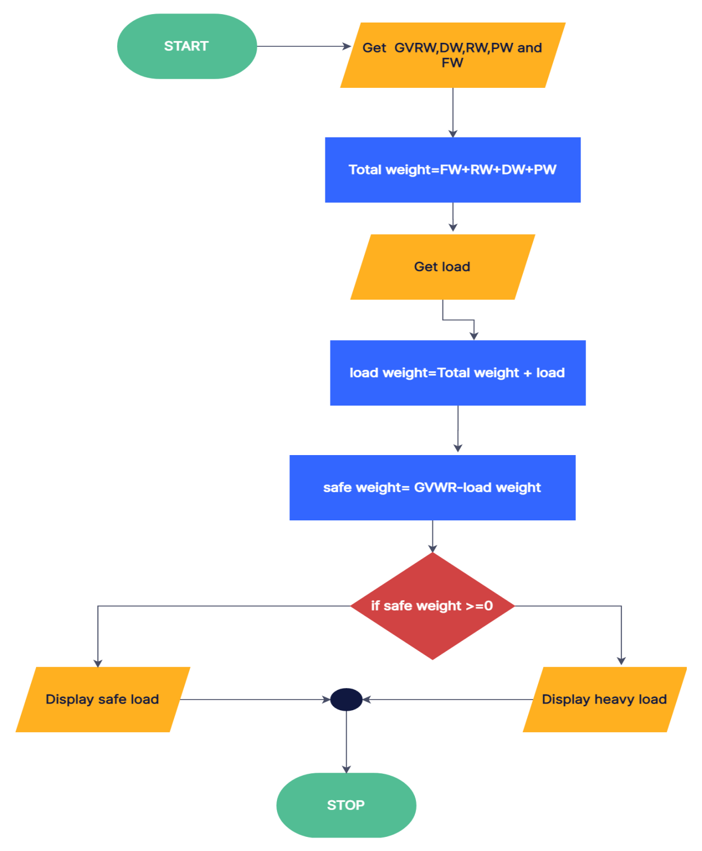

1.7 STUDENT GRADE ANALYSIS

**AIM:**

**To draw flowchart and write algorithm for the given problem.**

**ALGORITHM:**

**Step 1 : Start**

**Step 2: Read the no. of students ‘n’**

**Step 3: initialize i=1**

**Step 4 : If i<=n, True go to step 5, False go to step 15**

**Step 5: Read the marks m1,m,m3 and name of students**

**Step 6: total = m1+m+m3**

**Step 7: avg = Total/3**

**Step 8: If avg>=90&&avg=100;true go to 8.1;else go to 9**

**8.1: Print ‘Grade O’**

**Step 9: If avg>=75&&avg<90 ;true go to 9.1;else go to 10**

**9.1:Print ‘Grade A’**

**Step 10: If avg>=50&&avg<75;true go to 10.1; else go to 11**

**10.1:Print ‘Grade B’**

**Step 11: If avg>=35&&avg<50;true go to 11.1; else go to 12**

**11.1: Print ‘Grade C’**

**Step 12: If avg<35; true go to 12.1; else go to step 13**

**12.1:Print ‘Grade D’**

**Step 13: increment i by i++**

**Step 14: Print name and Grade**

**Step 15: Stop**

**RESULT:**

**Thus the algorithm is written and flowchart is drawn for the given problem.**

**FLOWCHART(STUDENT GRADE ANALYSIS):**

